**OSH Authorities – Cyprus**

Source: <https://oshwiki.eu/wiki/OSH_system_at_national_level_-_Cyprus>

* OSH Infrastructure

Scheme:

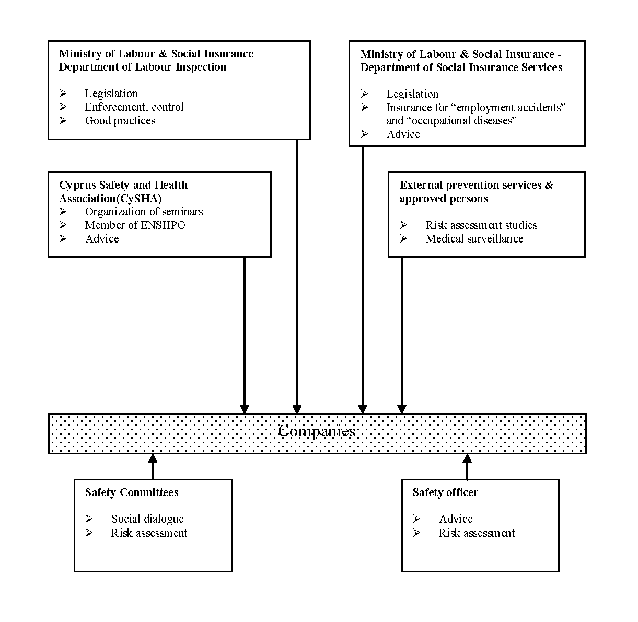

* OSH Authorities

|  |  |
| --- | --- |
| Name of the Authority | Department of Labour Inspection |
| Link | <http://www.mlsi.gov.cy/mlsi/mlsi.nsf/mlsi16_gr/mlsi16_gr?OpenDocument> |
| Short abstract | The Department of Labour Inspection (Labour Inspectorate) belongs to the Ministry of Labour, Wellfare and Social Insurance and is responsible for safeguarding adequate levels of safety and health at work. The Department consists of one area and five sectors:  a) The Safety and Health at Work Area b) The Machinery and Equipment Sector c) The Industrial Pollution and Control Sector d) The Air Quality Sector e) The Radiation Protection Sector f) The Chemical Substances Sector |
| Link to OSH wiki | <https://oshwiki.eu/wiki/OSH_system_at_national_level_-_Cyprus> |

Internal link to enforcement indicator by MS

* Compensation and insurance bodies

|  |  |
| --- | --- |
| Name of the Body | The Department of Social Insurance Services |
| Link | <http://www.mlsi.gov.cy/mlsi/mlsi.nsf/mlsi13_gr/mlsi13_gr?OpenDocument> |
| Short abstract | The **Department of Social Insurance Services** of the Ministry of Labour, Wellfare and Social Insurance is responsible for the administration of the Social Insurance Law (Law 41 of 1980-2007 and its Regulations). Based on the above legislation, a Social Insurance Scheme was put into operation in 1980. Law 41 covers “employment accidents” and “occupational diseases” and provides injury benefits (temporary incapacities), disablement benefits and death benefits. |
| Link to OSH wiki | <https://oshwiki.eu/wiki/OSH_system_at_national_level_-_Cyprus> |

* Research institutes

|  |  |
| --- | --- |
| Name of the Institute | NONE |
| Link |  |
| Short abstract | In Cyprus there is no particular research institute specializing on OSH. The eighth fundamental pillar of the Strategy on Safety and Health at Work for the Period 2007-2012 deals with the encouragement of scientific progress and research. The Strategy intends to promote the collaboration between universities, institutes and services in Cyprus and abroad in order to face OSH risks. Assignments of studies to suitable organizations are a means towards this end. |
| Link to OSH wiki | <https://oshwiki.eu/wiki/OSH_system_at_national_level_-_Cyprus> |

* Prevention Institutes

|  |  |
| --- | --- |
| Name of the Service | Cyprus Safety and Health Association (CySHA) |
| Link | <http://www.cysha.org.cy> |
| Short abstract | The Cyprus Safety and Health Association (CySHA) was founded in 1991. Its objective is to contribute and participate in efforts to promote health and safety at work and prevent risks. It has more than two hundred and fifty members. Most of them come from the private sector but many Labour Inspectors are also its members. From 2003 CySHA is an active member of the European Network of Safety and Health Professional Organisations (ENSHPO), which deals with the mutual recognition of qualifications in health and safety in Europe. |
| Link to OSH wiki | <https://oshwiki.eu/wiki/OSH_system_at_national_level_-_Cyprus> |

* Standardization Bodies

|  |  |
| --- | --- |
| Name of the Authority | The Cyprus Organization for Standardization (CYS) |
| Link | http://www.cys.org.cy |
| Short abstract | The Standardization, Accreditation and Technical Information Law (156(I)/2002) has allocated standardization activities to the Cyprus Certification Company which was renamed the Cyprus Organization for Standardization (CYS). It is the national standardization body and it participates in the European and international standardization process. “Mirror Committee 04” follows international activities in the health and safety sector. |
| Link to OSH wiki | <https://oshwiki.eu/wiki/OSH_system_at_national_level_-_Cyprus> |